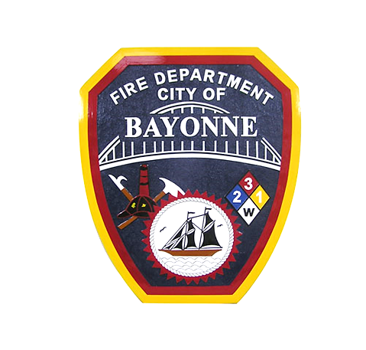

Dear Sir or Madam,

For over four decades, the Bayonne Fire Prevention Bureau has proudly sponsored the NJ Division of Fire Safety Poster Contest through its Fire Prevention and Community Safety Program. This contest serves as a vital educational tool, aimed at instructing school-aged children in the principles of fire prevention and safety.

During Fire Prevention Week, observed each October, all members of the Bayonne Fire Department engage in public fire education initiatives, reaching out to local schools and civic groups. This year, the Bayonne Fire Department’s Fire Prevention Bureau, the Bayonne Board of Education (BBOED), and Bayonne Economic Opportunity Foundation (BEOF) will be partnering to support this longstanding initiative.

BEOF respectfully requests your consideration of a donation to support the Bayonne Fire Prevention Bureau's Fire Prevention and Community Safety Program this year and help us make it something special for our community’s youth! Your generous contribution will assist in funding various aspects of the Fire Prevention Poster Contest, including prizes for our students, a ceremony to honor the contest winners, and all outreach efforts, encompassing the creation of promotional materials dedicated to this noble cause. Your contribution will significantly contribute to the success of this program in providing vital fire safety education services to Bayonne. Donations could be made with the provided QR Code. Checks can be made out to the Bayonne Economic Opportunity Foundation (BEOF)- please be sure to note "Fire Prevention Safety" in the memo line.

Your assistance is an invaluable component of our daily responsibilities, and we extend our heartfelt gratitude in advance for your thoughtful consideration of this request.

Sincerely,

BEOF & the Bayonne Fire Prevention Bureau

**Donate Here:**

