Monday | Tuesday | Wednesday | Thursday | Friday
2.  CLASS Observations | 3.  CLASS Observations | 4.  Learn more about building a secure parent-child relationship  https://eclkc.ohs.acf.hhs.gov/family-engagement/home-visitors-handbook/secure-parent-child-relationship | 5. | 6.
9.  CLASS Observations  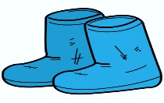 | 10.  Policy Council Officers Meeting 9:00 Center 3  ᴑ  CLASS Observations  ᴑ  Health Advisory Committee Meeting 2:45 | 11. | 12. | 13.  Parent – Child Connections Meeting 9:00 AM  MH&D Meeting 11:00
16.  Paula Micalizzi, Bayonne Children’s Librarian Visits  Center One | 17.  Raising Young Children in a New Country  Available in Arabic at  https://eclkc.ohs.acf.hhs.gov/sites/default/files/pdf/raising-young-children-new-country.pdf | 18.  Ways to Use Raising Young Children in a New Country: Supporting Early Learning and Healthy Development Handbook  https://eclkc.ohs.acf.hhs.gov/sites/default/files/pdf/ways-to-use-raising-child-guide-eng.pdf | 19.  Children’s X-mas Pizza Treat for Lunch  Monthly Education Staff Meeting 3:00 p.m.  First Period COR Ends  Tomorrow | 20.  Children dismissed at 12:15  Happy Holidays to You All
23.  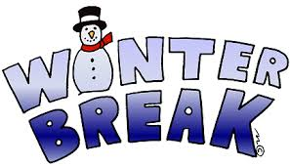  School Closed | 24.  School Closed | 25.  School Closed | 26.  School Closed | 27.  School Closed
30.  School Closed | 31.  School Closed | 1.  Happy  New  Year | 2.  Staff and Children return to School | 3.
BAYONNE HEAD START DECEMBER 2019 CALENDAR

